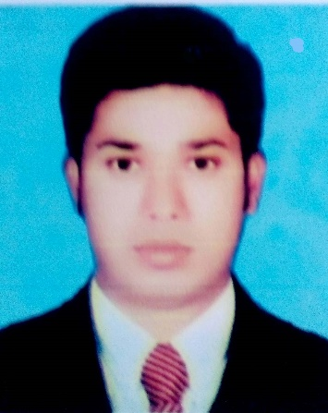**Curriculum Vitae**

**OF**

**MD. ZAHIDUL ISLAM –ZAHID**

Address : Ziarokhe, Boria , Kushtia

Cell Phone # +8801735 - 919029

Email: [jahidulkst33@gmail.com](mailto:jahidulkst33@gmail.com)

**CAREER OBJECTIVE:**

To obtain a position that will allow me to utilize my technical skills, experience and willingness to learn in making an organization successful.

**EXPERIENCE:**

1. **Senior Executive: ( 6 July 2019 – Continues)**

**Company: Runner Automobiles Limited**

**Department: Credit Sales**

**Duties / Responsibilities:**

* **Coordinating team brand and communication.**
* **Monitor and report on effectiveness fled installment Collection and Runner bank Account deposited ensures.**
* **Prepare professional branding plan and motivate branding time.**
* **Writing and presenting reports to senior management.**
* **Brief and train branding personnel.**
* **Writing and presenting monthly meeting reports.**

1. **Executive: ( 16 July 2016 – 5 July 2019)**

**Company: Runner Automobiles Limited**

**Department: Credit Sales**

**Duties / Responsibilities:**

* **Establish good relationships with customers.**
* **Encourage customers to know about Runner bands.**
* **Collecting installments from customers at specified time and Runner bank Account deposited ensures.**
* **Prepare professional daily, weekly and monthly plan and implement the plan.**
* **Daily performance reports are send to the senior boss in the mail.**
* **Writing and presenting monthly meeting reports.**

**Extra Experience :**

* **Transparency International Bangladesh ( TIB ) Social movement against corruption. Youth Engagement and Support -YES Member.**
* **Bangladesh Scouts: Team Leader Scouts & Rover Scouts Member.**
* **Bangladesh Ansar VDP Member.**

**Computer Literacy:**

* **Operating System Windows-xp**
* **MS-Word**
* **MS-Excel**
* **Power Point**
* **Adobe Photoshop**
* **Internet Browsing & E-mailing**
* **Runner IFS Software using**

**Educational Credentials:**

**Master’s of Business Studies (MBS)**

**Institution : Kushtia Govt. College, Kushtia**

**Discipline : Dept. of Management**

**Year of passing : 2012**

**Result : 1st class**

**Board : National University**

**Bachelor of Business Studies (BBS)**

**Institution : Kushtia Govt. College, kushtia**

**Discipline : Dept. of Management**

**Year of passing : 2011**

**Result : 2nd class**

**Board : National University**

**Higher Secondary Certificate (H.S.C)**

**Institution : Begum Hamida Siddique Collegiate School**

**Discipline : Business Studies**

**Year of passing : 2007**

**Result : 4.34 Out of 5, Grade (A)**

**Board : BTEB**

**Secondary School Certificate (S.S.C)**

**Institution : Begum Hamida Siddique Collegiate School**

**Discipline : Business Studies**

**Year of passing : 2005**

**Result : 3.45 Out of 5 , Grade (B)**

**Board : BTEB**

**Language Proficiency :**

* **Fluent in speaking both English & Bengali.**
* **Excellent writing and reading abilities both Bengali & English.**
* **Capable to writing and speaking Bengali & English in a professional way with natural flow.**

**Special Interest :**

* **Reading books.**
* **Traveling new places.**
* **Communicating with common people**
* **Continuous knowledge building as a means of professional development.**

**Personal Profile :**

**Name : Md. Zahidul Islam**

**Father’s Name : Md. Joynal Abedin**

**Mother’s Name : Mst. Sajeda Khatun**

**Date of birth : 05 January 1987**

**Nationality : Bangladeshi ( by brith)**

**National ID : 505 552 4986**

**Religion : Islam**

**Marital Status : married**

**Height : 5’-5”**

**Weight : 69kg**

**Blood Group : B + (positive )**

**Permanent Address : Vill- Ziarokhe, Post : Boria , P.S. = kushtia Sadar, Dist: kushtia .**

**Present Address : Puthis Bus stand , Post : Puthia, P-S = Puthia Dist: Rajshahi .**

**References :**

**Md. Abu Sahin Md. Faruk Uddin**

**Cash Officer Assistant Manager**

**Bangladesh Krishi Bank Runner Automobiles Ltd.**

**Mobile : 01717-205381 Mobile: 01730- 407308**

**I hereby, solemnly affirm that the above mentioned information is true to the best of my knowledge.**



**Signature of Candidate**

**Md. Zahidul Islam - Zahid**